Group:3
OBJECT ORIENTED PROGRAMMING:-
LAB ASSIGNMENT:-3

Q1. Create a class Student with private data members name and marks. Write a friend function to access and display these private data members?
Ans.1
#include<iostream>
using namespace std;
class Student
{
private:
string name;
int marks;
public:
void setdata()
{
name="Mohit Garg";
marks=85;
}
friend void display(Student s);
};
void display(Student s)
{
cout<<"Name:"<<s.name<<endl;
cout<<"Marks:"<<s.marks<<endl;
}
int main()
{
Student s;
s.setdata();
display(s);
}

Output:-

Q2. Create a class Number with two private data members a and b. Use a friend function to access these members and calculate and display their sum?
Ans 2.
#include<iostream>
using namespace std;
class Student
{
private:
string name;
int marks;
public:
void setdata()
{
name="Mohit Garg";
marks=85;
}
friend void display(Student s);
};
void display(Student s)
{
cout<<"Name:"<<s.name<<endl;
cout<<"Marks:"<<s.marks<<endl;
}
int main()
{
Student s;
s.setdata();
display(s);
}
Output:-

Q3. Create a class Employee with a private data member salary. Create two objects and use a friend function to compare their salaries and display the higher salary?
Ans 3
#include<iostream>
using namespace std;
class Employee
{
private:
int salary;
public:
void getSalary()
{
cin>>salary;
}
friend void compare(Employee e1, Employee e2);
};
void compare(Employee e1,Employee e2)
{
if(e1.salary>e2.salary)
{
cout<<"Higher Salary"<<e1.salary;
}
else
{
cout<<"Higher Salary"<<e2.salary;
}
}
int main()
{
Employee e1,e2;
cout<<"enter the Salary of Employee1:";
e1.getSalary();
cout<<"enter the Salary of Employee2:";
e2.getSalary();
compare(e1,e2);
}
Output:-

Q4 Create a class Student with a static data member to keep track of the number of objects created. Create three objects and display the total number of objects?
Ans4
#include<iostream>
using namespace std;
class Student
{
static int count;
public:
Student()
{
count++;
}
static void displaycount()
{
cout<<"Total no of object created:"<<count<<endl;
}
};
int Student::count=0;
int main()
{
Student s1;
Student s2;
Student s3;
Student::displaycount();
}
Output:-
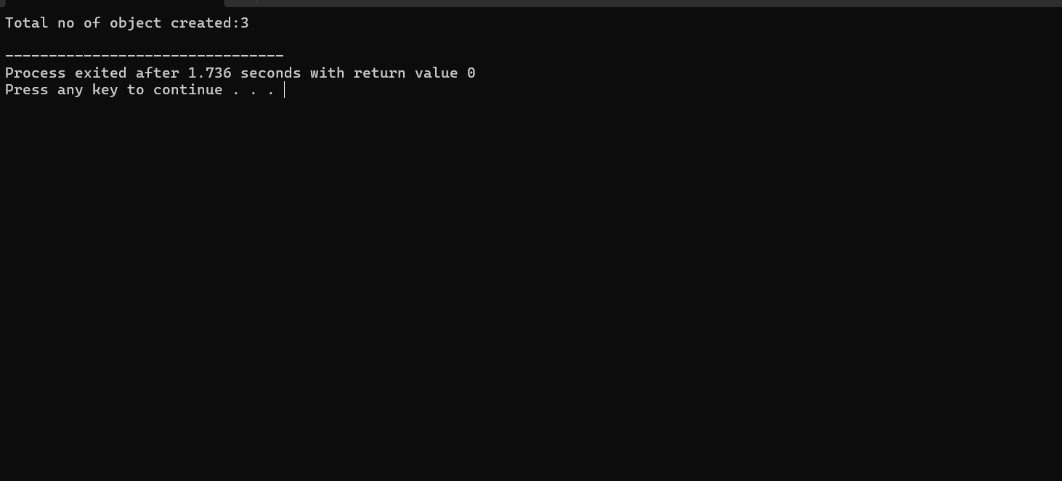
Q5. Create a class BankAccount with: Private data members: accountNo balance Static data member: totalAccounts ?
Ans 5.
#include <iostream>
using namespace std;
class BankAccount
{
private:
int accountNo;
float balance;
static int totalAccounts;
public:
BankAccount(int accNo, float bal)
{
accountNo = accNo;
balance = bal;
totalAccounts++;
}
friend void displayAccount(BankAccount A);
static void displayTotalAccounts()
{
cout << "Total Accounts Created: "
<< totalAccounts << endl;
}
};
int BankAccount::totalAccounts = 0;
void displayAccount(BankAccount A)
{
cout << "Account Number: " << A.accountNo << endl;
cout << "Balance: " << A.balance << endl;
cout << "------------------------" << endl;
}
int main()
{
BankAccount A1(101, 5000);
BankAccount A2(102, 7500);
BankAccount A3(103, 10000);
displayAccount(A1);
displayAccount(A2);
displayAccount(A3);
BankAccount::displayTotalAccounts();
}
Output:-
